**ASSIGNMENT-5**

**Q1. Discuss any 3 tools of project management.**

**ANS: Project Management Tools :-**

**1.**[**ProofHub**](https://www.proofhub.com/try/?utm_source=ProofHub.com%2FArticles&utm_medium=Referral&utm_campaign=Work%20%26%20Project%20management&utm_term=Content&utm_content=Top%2015%20Project%20Management%20Tools%20for%202018)

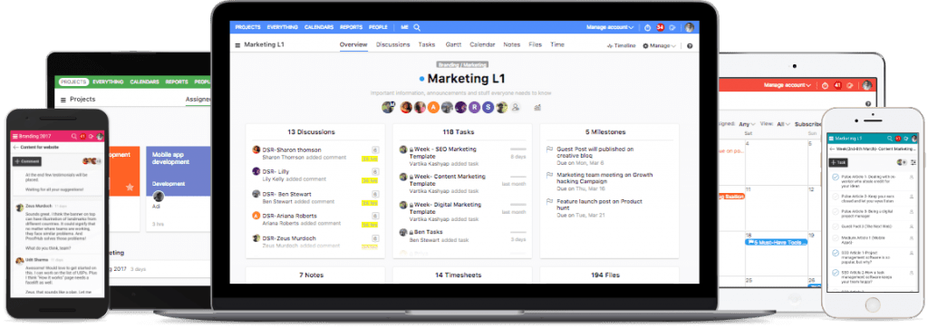

ProofHub is a versatile project management tool used by leading[organizations like NASA, Disney, Taco Bell](https://www.proofhub.com/customers), and many more. This all-in-one tool comes packed with powerful features to eliminate the need of depending on tens of different tools to run your project.

**Whether you’re a team of 10, 50, or 500 project members**, ProofHub is an extremely scalable solution for managing project activities. Managers can use it to take charge of all kinds of project tasks, side-by-side full control on project communication. One of the highlights of ProofHub is that it brings must-have project tools such as files, time tracking, team chat, calandar – everything you can imagine in a neat web portal.

**The latest release is ideal for work-from-home teams** and outsourced projects because it’s 100% cloud-enabled. Team members can log in to a single project management tool for all their project needs. Using the secured IP feature that lets you restrict IP addresses accessing your ProofHub account, you can truly ensure data security and safe telecommuting.

Another useful highlight of ProofHub is its **digital proofing feature**. Cross-functional teams that work on web design, social media, and advertising projects can greatly streamline their creative process. Organize project flows into “pending”, “in-review” and “approved” stages with all the key stakeholders chiming in seamlessly.

**=>Features:**

Task Management

Time Management

Project Communication

Collaboration

Project Planning

**Project Reporting**

Bottom of Form

**2. Scoro**

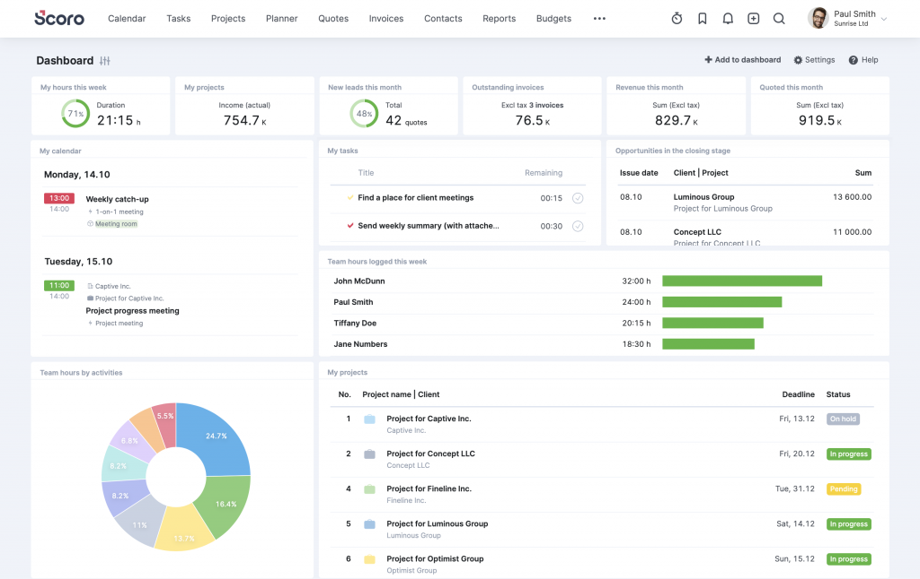

[Scoro](https://www.scoro.com/) is known as one of the most comprehensive[business management software](https://www.proofhub.com/articles/best-business-management-software) for professional and creative services. For those who wish to bring structure to your work, Scoro is the right pm tool for you.

**Features:**

* A single place for projects, clients, and teams
* Be organized in every aspect of your business with seamless workflow
* Get a real-time overview and automated reports
* Can be integrated with tools like DropBox, Mailchimp, Outlook, and more

**3. Workzone**

[](https://www.proofhub.com/try?utm_source=https%3A%2F%2Fwww.proofhub.com%2Farticles&utm_medium=referral&utm_campaign=Project+management+tools&utm_term=Best+Project+Management+Tools+%26+Software+&utm_content=ctabanner)

Workzone is built by a highly dedicated team to help individuals and organizations gain better control and visibility in work management. It gives them a central place to manage and share work, so everyone stays on the same page.

**Features:**

* Get top-level reports so everyone knows what’s next on the list
* Makes way for faster communication
* Features like creating tasks, to-do lists, and sharing files easily improves collaboration
* Set permission for different users including clients

**4. Filestage**



[Filestage](https://filestage.io/) is an enterprise-ready marketing [project management software](https://www.proofhub.com/articles/project-management-software) that helps teams to get their project deliverables reviewed and approved faster. Filestage streamlines organizes and automates feedback on deliverables throughout the proofing process while reducing errors and ensuring compliance guides are met. Enable colleagues and clients to view and annotate project deliverables (such as documents, images, or videos) in real-time for marketing projects, video production, website design, product catalogs, or anything else – and to approve files when they are complete.

**Features:**

* Build consistent review and approval processes
* Comment on videos, documents, images, and audio files in real-time
* Clear deliverable version management
* Project dashboard to keep an overview of all deliverables

**5. Proprofs**

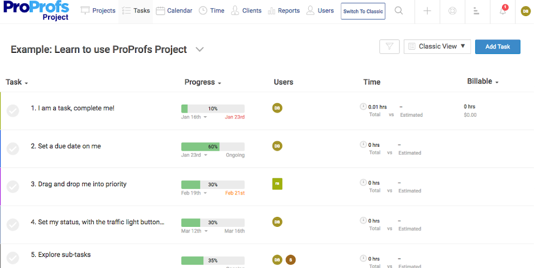

ProProfs Project is one of the simple and feature-packed project management tools designed to help businesses of all sizes manage, track, and execute projects with ease. It brings all your projects under one roof allowing your teams to work on them collaboratively. They can share files on the go, discuss roadblocks, give feedback via task comments, and get real-time notifications on project developments.

From assigning and prioritizing tasks to tracking and executing them, the tool helps you do it all. You can even create timesheets for each team member, manage billable and non-billable hours and generate invoices.

**Features:**

* Gantt charts
* Shared Calendar
* Kanban Board
* Custom Workflow
* Timesheets
* Insightful reports
* Invoice generation
* Drag and drop functionality

**Q2:** **how is PERT helpful to managers**?

**ANS=>** There are several techniques and planning tools that are a part of project management. One of them is PERT. Before applying these techniques, you must know the basic requirements of the project that are needed to be fulfilled.

PERT stands for Program Evaluation and Review Technique and is one of the planning tools used in project management. To carry out a project, especially a complex one, you need to know and estimate all of its details. Details include scheduling, organizing, and coordinating tasks within a given project.

PERT is all about calculating the estimates, especially time estimates. PERT technique is often used by project managers to estimate how much time a specific task within a project will take. PERT gives its results based on time estimates.

There are three time estimates. They’re optimistic, most likely, and pessimistic. An optimistic estimate identifies the quickest time in which a certain task can be completed. Most likely helps to identify the time between maximum and minimum. Pessimistic is all about estimating the maximum time that each task will take before it can be complete.

## ****How does PERT work****

PERT planning tool is widely used by project managers so that they can have an idea about how much duration, and the cost they need to plan for a certain type of project. It is a network of numbered boxes and arrows. Numbered boxes are also referred to as nodes and represent project events within a project. These boxes can either be rectangular or circular.

These nodes are connected by labeled lines that represent different kinds of tasks within a specific type of project. Arrows indicate task sequence, and numbers represent the time allotted. The sequence of the tasks must be in order and it is necessary to be followed by all the team members for the PERT technique to be effective.

Concurrent arrows represent tasks that are dependent on each other and without completing these you can’t proceed further. Diverging sets of arrows represent independent tasks that aren’t linked to any of the tasks. Tasks comprising diverging arrows mean that they can be completed simultaneously.

However, it is not the case with dependent tasks. By making a PERT chart a project manager and their team members can effectively calculate the risks and time estimates of the whole project. Moreover, PERT represents the data and timeline through graphical illustration which makes it easy for the members and the project manager to comprehend it.

After knowing What is PERT in Project Management. We should know its benefits.

**Benefits of using PERT:**

There are many benefits of using the PERT technique. Some of the most effective ones are listed below.

* **Helpful in knowing the time estimates**

By using the PERT technique, a project manager can know about the completion time of a specific project. PERT technique uses three, time estimates. These are optimistic, most likely, and pessimistic. By knowing these estimates a project manager can identify how much time to spend on a certain task.

* **Dependency is the key**

PERT technique’s another advantage is that it helps the project manager to know which tasks are dependent on each other. It also enables the project manager and the team to give a clear idea of where to begin.

It helps the project manager to know which task must be completed first so the project can be further escalated. Knowing the dependency of the tasks helps to maintain the order of the project.

* **Helpful in analyzing different paths**

By using the PERT technique, a project manager can visually analyze all the possible paths that can save time. It helps the project manager to complete the project in the most effective way.

Moreover, it enables the project manager to know the obstacles, and risks that might occur when a certain path is chosen. It also enables the project manager to know the longest route that a project will take to be complete. This path is also known as the critical path.

* **Improves strategy**

By using the PERT technique, a project manager can identify what strategies to apply in a project and what to avoid. Team members gain significant knowledge by using the PERT technique. It helps to build communication between the project manager and the team members.

Team members visualize complex problems and make different strategies through the PERT planning tool and share with their project manager. As a result, strategies to overcome complex problems are significantly improved.

* **Helps to identify the resources needed**

By using the PERT technique, a project manager can identify how many resources are needed for a specific type of project. PERT technique shows all of the events, and tasks within a project through graphical illustration.

So, with the help of this, a project manager can know and gather all the resources that a single task might need. It gives an idea to the project manager about the maximum number of resources needed. This will help the project manager to complete a single task, cost-effectively, and without any obstacle.

**How to create PERT in project management**

Creating PERT in project management contains different phases and stages. All of them are listed below.

* **Be aware of the tasks, and activities**

To create a successful, and effective PERT chart you should be aware of the tasks, events, and different types of activities that are required in your project. You should know all general, and specific details about your project for you to create a PERT chart.

Define and mention both, dependent, and independent tasks that are involved in your project. Mention the details that these tasks contain. By mentioning these details you’ll be able to know which tasks are the most important.

Moreover, you should have an idea about which tasks are connected and which aren’t. To make a PERT chart, you must have a full understanding of the processes that your project will undergo. Also, make sure to mention the final goal, and milestone of your project. This will give you a clear idea of what you’ve to accomplish by the end of your project.

* **Sequence is the key**

To create a PERT chart in project management, make sure you know the correct sequence of your tasks and events. Mention the sequence correctly while creating a PERT chart in project management.

You will not be able to make a PERT chart if you aren’t able to identify the correct sequence of your tasks. This will harm your project and you’ll not be able to identify the starting point of your project.

* **Create different nodes, and arrows**

To create a PERT chart in project management, make sure that you draw different nodes and arrows. Make sure that you put all the events in the drawn nodes. Link these different nodes by the labeled lines. Labeled lines represent project tasks.

Be sure to draw arrows, both, concurrent, and diverging. To create a PERT chart in project management, make sure that you know which task is to be completed in which sequence.

* **Time is of the essence**

To create a PERT chart in project management, make sure that you know the proper time estimates. Be sure that you know how to calculate the three time estimates. The three time estimates are optimistic (the minimum amount of time required to complete a specific task Pessimistic (the maximum amount of time required to complete a specific task), and most likely.

Once you’re able to calculate how much time a certain task will take, and in what category of the time estimates your task falls, proceed further in making your PERT chart. Don’t proceed ahead without calculating the time estimates, as this is the main objective of the PERT technique.

* **Critical path**

To create a PERT chart successfully in project management, make sure that you know how to calculate the critical path of your project. Calculating the critical path requires the above-mentioned steps to be completed successfully. Without completing these steps you’ll not be able to calculate the critical path of your project.

After completing the above steps you’ll be able to get a clear idea of how to complete your project in the allotted time. With the help of this, you can easily determine the critical path which is also the longest path that is required by your project to be complete.

To create a PERT chart in project management, make sure that you also know the problems, risks, and uncertainties that your chosen path might have. Also, make sure that you highlight your paths especially the one you’re considering choosing. This will save both time, and effort later on.

**Q3: What are the major reasons of stress in a project ? What are the solutions to them?**

### ANS=> The major reasons of stress in a project:-

### Reason for Stress: Miscommunication

By far the biggest source of stress for teammates is miscommunication. With 52% of respondents citing lack of information, 42% accusing a lack of collaboration, and another 24% who are unsure of their own role in the project.

Miscommunication is frustrating for everyone involved in collaborative projects. And it’s something that has only been exasperated with the rise of remote work. Because emojis don’t always convey how we feel.

**How to Reduce this Stressor:**

Gantt charts and Kanban boards are the most commonly used [project management tools](https://www.ganttic.com/project-management) for a reason. They visually communicate what needs to be done to your whole team. And cloud-based versions can be deployed quickly and cheaply, meaning your team will never again question what they need to do.

### Reason for Stress: Lack of Accountability

Coming in with 44% and 37% of the respondents’ votes for top workplace stressors, is unclear task accountability and team members not doing their work.

This can mean that PMs are not making it clear what their teams need to be doing. And who actually does what. Which can go on to lead other issues with efficiency down the road.

Plus, when others aren’t pulling their load, team dynamics start to break down. Causing stress and hostility amongst members.

**How to Reduce this Stressor:**

Hold people accountable by showing them what they need to do. Basic [project resource management](https://www.ganttic.com/blog/what-is-resource-management) practices used by the PM can help alleviate this stress by allocating tasks to specific people.

If you use [resource planning software](https://www.ganttic.com/blog/resource-planning-tools), you create an overview of the entire team. Meaning no one can get away with not doing their individual tasks. Plus, extra features like deadlines, tasks’ dependencies (clearly indicating which tasks come first) and project milestones make it easy to see that everything is on track.

### Reason for Stress: Project Scheduling and Timeline Issues

Problems arising from project scheduling cause stress for 49% and another 47% of respondents, citing unrealistic project goals and ever-changing deadlines respectively. Not surprisingly, unrealistic timeline expectations are also a main reason [why projects end up failing](https://www.ganttic.com/blog/why-do-projects-fail-miserably).

Things like changing deadlines can be made worse if your team isn’t used to using a proper project planning tool. Because making and communicating changes to a [spreadsheet](https://www.ganttic.com/compare-us) isn’t only stressful for your team. But it’s stressful for you as PM.

**How to Reduce this Stressor:**

Engaging in some bottom-up estimating techniques such as analogous estimating can help you figure out exactly how long past tasks took. Use these figures to then more accurately [estimate your current tasks’ duration](https://www.ganttic.com/blog/how-to-estimate-task-duration-when-planning-resources). And plan projects with more precision.

And if you do find out down the road that you need to make changes to your project’s dates. Don’t worry! If you’re using resource planning software, just click on a task and make some adjustments.

### Reason for Stress: Leadership Issues

All teams, no matter their size, [require a leader](https://sloanreview.mit.edu/article/why-teams-still-need-leaders/). Giving the extra push, show of support, or insight needed to get the job done. Without effective leadership, employees are more prone to stress. With 44% citing unclear leadership and 28% accusing lack of involvement from project sponsors to be known stressors.

**How to Reduce this Stressor:**

When it comes to getting project sponsors more involved, there’s not always something you can do. Though you can try!

There’s a number of ways to [engage your project sponsor.](https://www.ginaabudi.com/5-ways-to-engage-the-project-sponsor/) Such as keeping them in the loop on project progress. Sharing project plans or sending them reports can help them feel more involved from the outset, so that they eventually become more involved.

**Q4: In an organization, how right people are selected for right jobs?**

ANS=> Employing the right candidate for the right job and at the right time. This is one of the most important aspects of a successful hiring process. This takes us to the fact that the recruitment process should be effective in terms of both cost and time. It takes a lot of resources for an organization to recruit the right people, so it becomes equally important to make the right choices right from the start. A good hire defines your business and the future of business is dependent on a good hiring process. A good hire will have many implications for your business, from growth and profitability to customer satisfaction and quality. This all starts with the adoption of an organized, structured and a comprehensive recruitment process making sure to position your business for success by attracting the right candidates. Having the right talent builds the culture, drives the revenue and eventually helps an organization to outdo the competitors. Failing to have an effective recruitment system will lead to the exact opposite effects resulting in the waste of resources, time and money.

Defining the hiring process is very important. But what is more important is what goes behind the scenes. Some of the most comprehensive steps in a good recruitment process include:-

**1. Designing the job by identifying and creating the role to be filled:**The idea is not to get as many candidates as possible but to get the right candidates. So it is important to define and describe the roles and responsibilities clearly.

**2. Promoting and marketing the open position to attract the right candidates:** This is considered to be the most important step in attracting the right candidates for application. This calls for research to be conducted in order to find out where the best candidates are looking for similar jobs.

**3. Selecting the candidates, and evaluating the candidates aligning with the organization culture:** Be active and responsive. Maintain proper communication with prospective employees and always be reflective of the company values and culture.

**4. Confirming the skills of the selected candidates:**Remember you are not hiring a friend but a good fit for the organization. The emotional feeling can result in a costly mistake. This could be best done by going beyond and understanding of the past experience, cultural fit, attitude, and accountability.

Some of the organization fail to employ the right person even after using a lot of money and time. This is mainly because of the inconsistency which compromises quality and compliance. Another reason for such a failure is to fail to identify the right time to hire. Hiring should be only done when there is a need, and what is important is the awareness of the early warning signs when that time is coming.